Intro to religion notebook

We look closely at hate crime by religious bias motivation (using same data NYPD 2017 1st q-2019 2nd q)

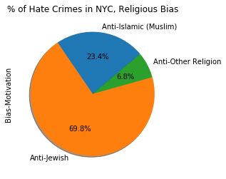

Most crimes are against jews (make a point, provide some stats new York city has largest jewish population etc)

At this point we’re making an assumption that large percentage of jewish population makes crimes against jews most common, so lets look closely into the neighborhoods.

Census data doesn’t provide info on religion so let’s count places of worship (synagogues and mosques) in areas where hate crimes were committed to get estimates of religious population.

Heat map of Anti-Jewish Crime

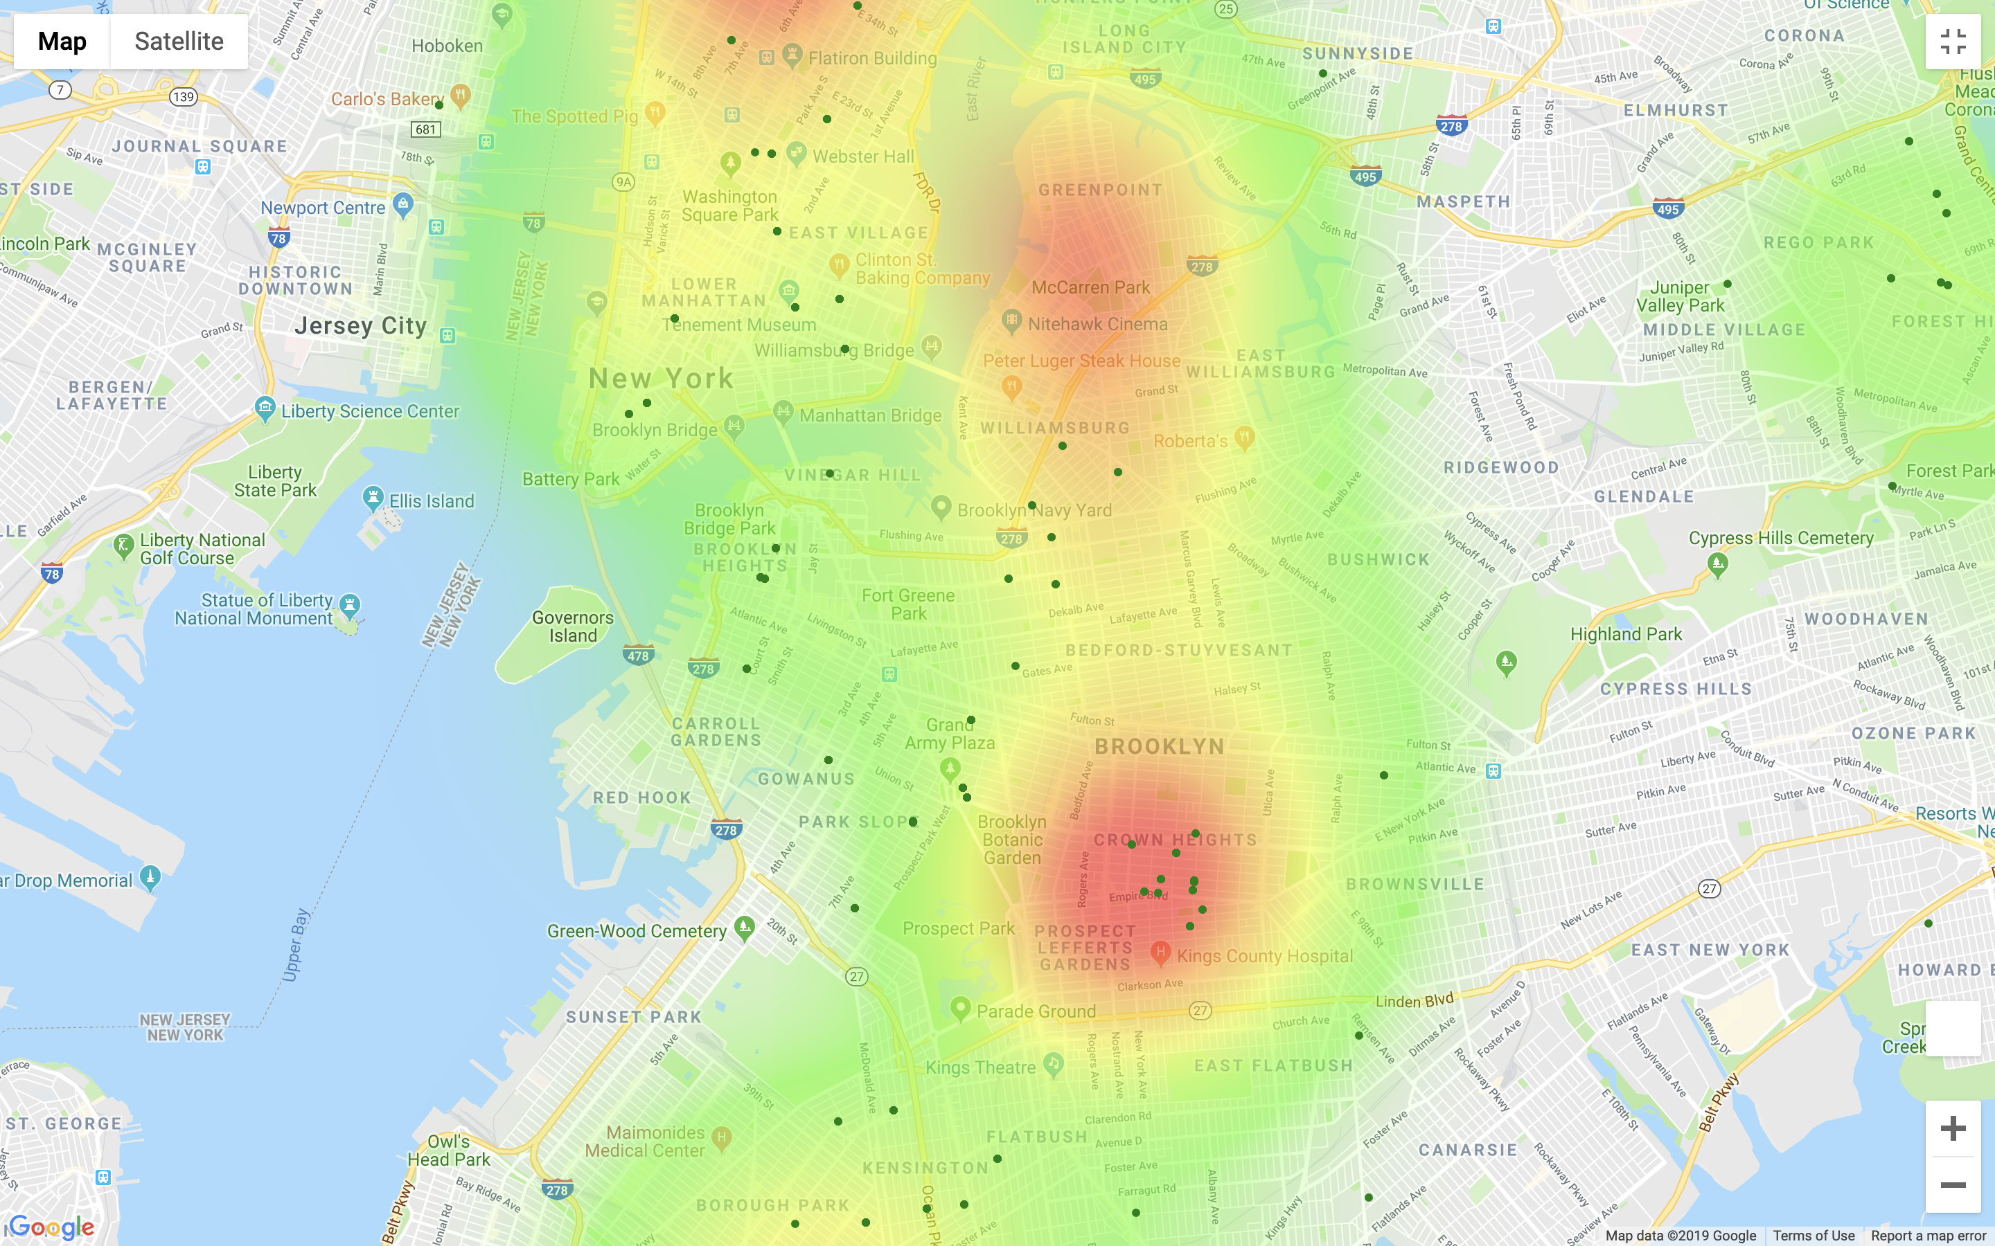

Heat map represents anti-jewish hate crimes, green dots represent synagogues. We can see that hate crimes agains jewish people happen in places with highest concentration of synagogues.

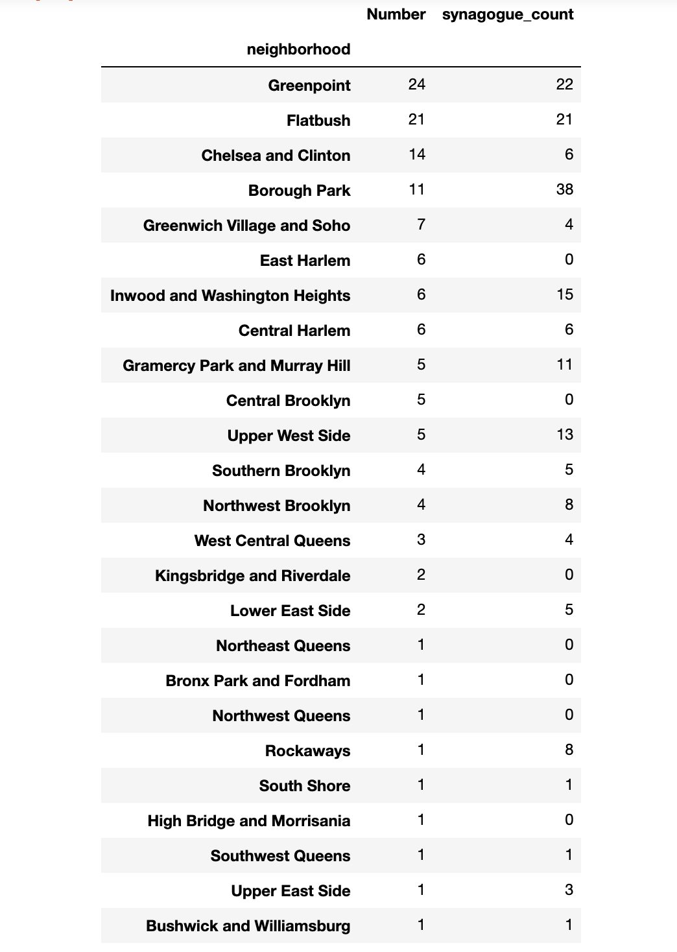

Out of top 5 most hate crime committed there are also top 3 neighborhood with highest number of synagogues. Certain neighborhoods stand out as safe (more synagogues less crime) and certain are more criminal ((add a little more here based on questions #1 and #2)).

Now lets try the same for crimes against muslims, let’s count mosques around each precinct.

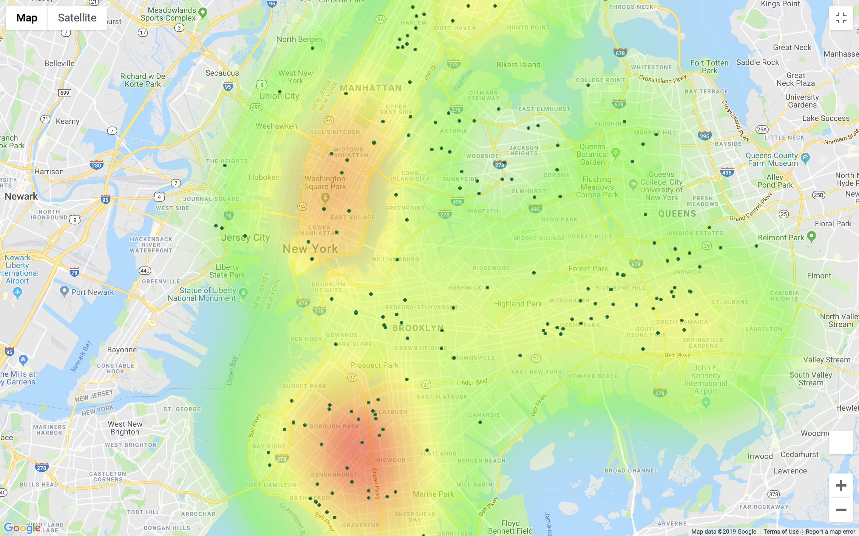

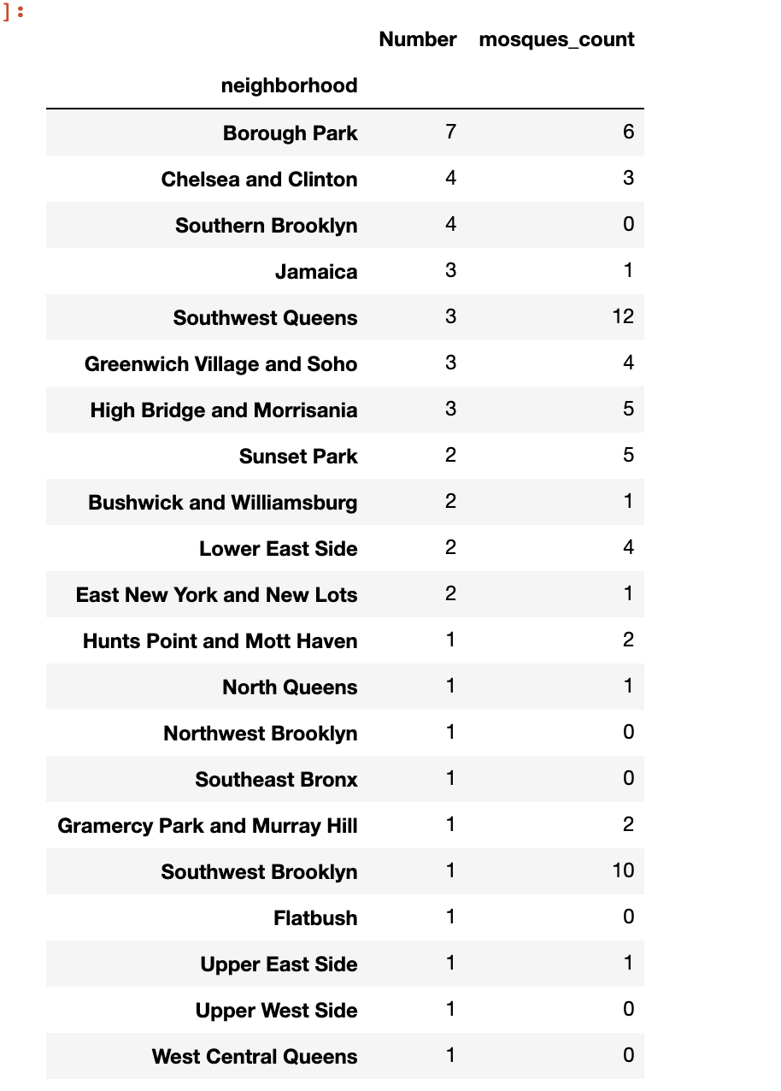

Kind of same picture: hate crime is proportional to number of mosques with certain safe neighborhoods with more mosques and less crime. And some neighborhoods with high crime rate overall.

Too much hate in borough park, probably because of different religious minority groups living close to each other. And safe neighborhoods usually have one minority group dominating